**Trường Đại Học FPT**

**Lớp IA1604**



**Database lưu trữ dữ liệu hệ thống tính điểm**

**cho sinh viên trường đại học FPT**

**Bài assignment kết thúc môn học**

**DBI202 – kì Summer 2022**

Sinh viên: Tạ Việt Nam

Mssv: HE160666

Lớp: IA1604

**Mục Lục**

a)

- Theo em thấy, **Student Grading Management Sub-System** cần có 3 bảng

* Bảng 1 : Assessment

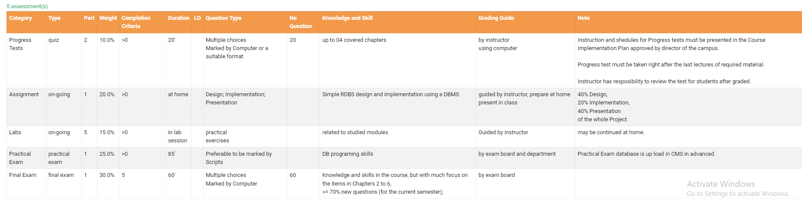

Có 10 attributes : Category, Type, Part, Weight, Completion Criteria,

Duration, LO, Question Type, No Question, Knowledge and Skill

-Category :

+Biểu thị những thành phần điểm

+Data type: varchar(15) 🡺 primary key

+Not null

-Type:

+Biểu thị hình thức kiểm tra

+Data type: varchar(15)

+Not null

-Part:

+Biểu thị số lượng bài kiểm tra

+Data type: int()

+Not null

-Weight:

+Phần trăm số điểm của từng category

+Data type: varchar(5)

+Not null

-Completion Criteria:

+Mức điểm tối thiểu cần đạt của từng category

+Data type:

+Not null

-Duration:

+Thời lượng của từng category

+Data type: varchar(20)

+Not null

-LO

+

-Question Type:

+Biểu thị cách thức kiểm tra

+Data type: varchar(100)

+Not null

-NO question:

+

-Knowledge and Skill:

+Những kiến thức và kĩ năng cần nắm vững

+Data type: varchar(100)

+Not null

*Bảng 2 : Subject and Course

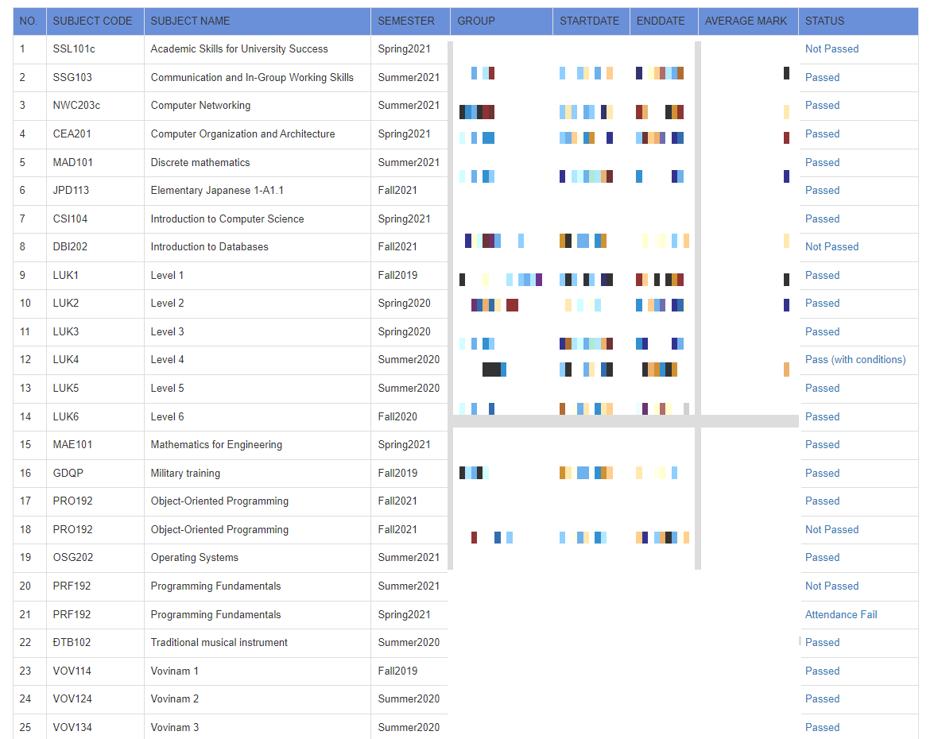

Có 9 attributes : No , Subject Code , Subject Name , Semester , Group , Startdate , Enddate , AverageMark , Status

-NO:

+ Số lượng môn , khóa học

+ Data type : int

+ Not null

-Subject Code :

+ Mã môn học

+Data type : varchar(100)

+ Not null

-Subject Name :

+ Tên đầy đủ của môn học

+ Data type : varchar(100)

+Not null

-Semester :

+ Hiển thị kì học

+ Data type : int

+ Not null

-Group :

+ Tên lớp học theo kì học và khóa học

+ Data type : varchar(100)

+ Not null

-StartDate :

+ Thời gian bắt đầu kì học

+ Data type : Datetime

+ Not null

-Enddate :

+ Thời gian kết thúc kì học

+ Datatype : Datetime

+Not null

-Average Mark :

+ Điểm số trung bình

+ Data type : int

+ Not null

-Status :

+ Mô tả tổng kết quá trình học của sinh viên :

. Passed

.Not Passed

.Passed with condition

*Bảng 3 : Bảng điểm cá nhân của sinh viên

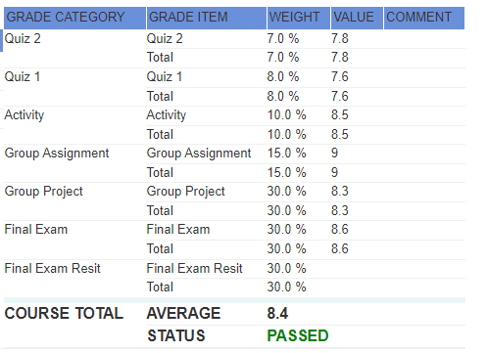

Có 5 attributes : Grade category , Grade item , weight , value ,comment

-Grade category :

+Danh sách và tên các đầu điểm :

- Progress Tests ( Quiz )

- Assignment ( Person, Group )

- Labs

- PE ( Practice Exam )

- FE ( Final Exam )

- Final Exam Resit

- Grade item :

+ Tên và tổng đầu điểm :

. Item

. Total

-Weight :

+ Tỉ lệ % điểm thành phần , cũng có ở bên FLM

+Data type: varchar(5)

+Not null

-Value :

+ Điểm sinh viên đạt được trên thang điểm quy chuẩn

+ Data type : int

+ Not null

**Xác định các entities và relationships**

**Xác định các entities** :

Thực Thể 1: Student

- StudentID

-FirstName

-LastName

- DoB

- Gender

- Address

-Email

Thực Thể 2: Class

- ClassID

- ClassName

- EndDate

- StartDate

Thực thể 3 : Student_Class

-ClassID

-StudentID

Thực Thể 5: Subject

- SubjectID

- SubjectName

Thực Thể 4: Lecture

- LecID

- Email

- Firstname

- Lastname

- Gender

- Dob

-Report

Thực Thể 6: Class_Lecture

- ClassID

- LecID

Thực thể 7:Grade

-GradeID

-SubjectID

-Total

-Status

Thực Thể 8: Grade_ Detail

-ID

- GradeID

- weight

- SubjectID

- Item

- value

- comment

Thực Thể 9: Subject_Term

- idSubject

- idTerm

Thực Thể 10: Term

- _TermID

- TermName

Thực Thể 11: Student_subject

-StudentID

-SubjectID

**Phân Chia Các Entities Và Relationships**

## Entity Students <-> Entity Class

Mô Tả: Một Student có thể đăng kí học nhiều Class Và 1 Class có thể có nhiều Student đăng kí học.

-> Xác Định Quan Hệ Giữa Entity Students Và Entity Class là quan hệ nhiều nhiều ( n-n )

🡺 Bảng Student_Class được tạo ra

## Entity Class <-> Entity Lecturers

Mô Tả: Một Class chỉ có thể được phụ trách bởi đúng 1 Lecturer và 1 Lecturer có thể phụ trách nhiều class.

-> Xác Định Quan Hệ Giữa Entity Class Và Entity Lecturers là quan hệ một nhiều ( 1-n )

## Entity Student <-> Entity Subject

Mô Tả: Một Student có thể đăng kí học nhiều Subject Và 1 Subject có thể có nhiều Student đăng kí học.

-> Xác Định Quan Hệ Giữa Entity Students Và Entity Class là quan hệ nhiều nhiều (n-n)

🡺Bảng Student_Subject được tạo ra

## Entity Term<-> Entity Subject

Mô Tả: Một kì học có thể có nhiều Subject Và 1 Subject có thể xuất hiện nhiều tại 1 kì học.

-> Xác Định Quan Hệ Giữa Entity Students Và Entity Class là quan hệ nhiều nhiều (n-n)

🡺 Bảng Subject_Term được tạo ra

## Entity Grade Detail<-> Entity Grade

Mô tả :Một Grades có thể tổng hợp từ nhiều Grade Detail và 1 Grade Detail chỉ có thể đưa vào 1 Grade duy nhất.

-> Xác Định Quan Hệ Giữa Entity Grade Và Entity Grade Detail là quan hệ một nhiều ( 1-n )

## Entity Grade <-> Entity Subject

Mô tả :Một Grades có thể mô tả điểm của nhiều Subject nhưng 1 Subject chỉ có thể đưa vào bảng điểm 1 Grade duy nhất.

-> Xác Định Quan Hệ Giữa Entity Grade Và Entity Subject là quan hệ một nhiều ( 1-n )

## **Chuẩn Hóa Thuộc Tính Các Attribute Trên Từng Bảng**

1. **Table Students**

|  |  |
| --- | --- |
| **Atrtributes** | **Type** |
| StudentID | Varchar(10) |
| FirstName | Nvarchar(10) |
| LastName | Nvarchar(50) |
| DoB | Date |
| Address | Nvarchar(150) |
| Email | Varchar(100) |
| Gender | bit |

1. **Table Class**

|  |  |
| --- | --- |
| **Attributes** | **Type** |
| ClassID | Int |
| ClassName | Varchar(50) |
| Start_Date | Date |
| End_Date | Date |

1. **Table Student_Class**

|  |  |
| --- | --- |
| **Attributes** | **Type** |
| ClassID | Int |
| StudentID | Varchar(10) |

1. **Table Lecture**

|  |  |
| --- | --- |
| **Attributes** | **Type** |
| LecID | Int |
| Email | Varchar(100) |
| FirstName | Nvarchar(10) |
| LastName | Nvarchar(50) |
| Gender | Bit |
| Dob | Date |
| Report | Nvarchar(50) |

1. **Table Class_Lecture**

|  |  |
| --- | --- |
| **Attributes** | **Type** |
| LecID | Int |
| ClassID | int |

1. **Table Subjects**

|  |  |
| --- | --- |
| **Attributes** | **Type** |
| SubjectID | Int |
| SubjectName | Varchar(50) |

1. **Table Student_Subject**

|  |  |
| --- | --- |
| **Attributes** | **Type** |
| StudentID | Varchar(10) |
| SubjectID | Int |

1. **Table Term**

|  |  |
| --- | --- |
| **Attributes** | **Type** |
| TermID | Int |
| TermName | Varchar(50) |

1. **Table Subject_Term**

|  |  |
| --- | --- |
| **Attributes** | **Type** |
| TermID | Int |
| SubjectID | int |

1. **Table Grade**

|  |  |
| --- | --- |
| **Attributes** | **Type** |
| GradeID | Int |
| Status | Varchar(255) |
| SubjectID | Int |
| Total | Float |

1. **Table Grade Detail**

|  |  |
| --- | --- |
| **Attributes** | **Type** |
| ID | Int |
| GradeID | Int |
| Weight | Int |
| Category | Nchar(255) |
| Item | Nchar(255) |
| Comment | Nchar(255) |
| Value | float |

## **Xác Định Primary Key, Foriegn Key, Attributes Các TABLES**

1. **Table Students**

|  |  |  |  |
| --- | --- | --- | --- |
| **Atrtributes** | **Type** | **Requires** | **Key** |
| StudentID | Varchar(10) | Not null | Primary key |
| FirstName | Nvarchar(10) | Not null |  |
| LastName | Nvarchar(50) | Not null |  |
| DoB | Date | Not null |  |
| Address | Nvarchar(150) | null |  |
| Email | Varchar(100) | Null |  |
| Gender | bit | Not null |  |

1. **Table Class**

|  |  |  |  |
| --- | --- | --- | --- |
| **Attributes** | **Type** | **Requires** | **Key** |
| ClassID | Int | Not null | Primary key |
| ClassName | Varchar(50) | Not null |  |
| Start_Date | Date | Not null |  |
| End_Date | Date | Not null |  |

1. **Table Student_Class**

|  |  |  |  |
| --- | --- | --- | --- |
| **Attributes** | **Type** | **Requires** | **Key** |
| ClassID | Int | Not null | Primary _ ForeignKey |
| StudentID | Varchar(10) | Not null | Primary _ ForeignKey |

1. **Table Lecture**

|  |  |  |  |
| --- | --- | --- | --- |
| **Attributes** | **Type** | **Requires** | **Key** |
| LecID | Int | Not null | Primary key |
| Email | Varchar(100) | Not null |  |
| FirstName | Nvarchar(10) | Not null |  |
| LastName | Nvarchar(50) | Not null |  |
| Gender | Bit | Null |  |
| Dob | Date | Null |  |
| Report | Nvarchar(50) | Null |  |

1. **Table Class_Lecture**

|  |  |  |  |
| --- | --- | --- | --- |
| **Attributes** | **Type** | **Requires** | **Key** |
| LecID | Int | Not null | Primary_Foreign key |
| ClassID | int | Not null | Primary_Foreign key |

1. **Table Subjects**

|  |  |  |  |
| --- | --- | --- | --- |
| **Attributes** | **Type** | **Requires** | **Key** |
| SubjectID | Int | Not null | Primary key |
| SubjectName | Varchar(50) | Not null |  |

1. **Table Student_Subject**

|  |  |  |  |
| --- | --- | --- | --- |
| **Attributes** | **Type** | **Requires** | **Key** |
| StudentID | Varchar(10) | Not null | Primary_Foreign key |
| SubjectID | Int | Not null | Primary_Foreign key |

1. **Table Term**

|  |  |  |  |
| --- | --- | --- | --- |
| **Attributes** | **Type** | **Requires** | **Key** |
| TermID | Int | Not null | Primary key |
| TermName | Varchar(50) | Not null |  |

1. **Table Subject_Term**

|  |  |  |  |
| --- | --- | --- | --- |
| **Attributes** | **Type** | **Requires** | **Key** |
| TermID | Int | Not null | Primary_Foreign key |
| SubjectID | int | Not null | Primary_Foreign key |

1. **Table Grade**

|  |  |  |  |
| --- | --- | --- | --- |
| **Attributes** | **Type** | **Requires** | **Key** |
| GradeID | Int | Not null | Primary key |
| Status | Varchar(255) | Null |  |
| SubjectID | Int | Not null | Foreign key |
| Total | Float | Null |  |

1. **Table Grade Detail**

|  |  |  |  |
| --- | --- | --- | --- |
| **Attributes** | **Type** | **Requires** | **Key** |
| ID | Int | Not null | Primary key |
| GradeID | Int | Not null | Foreign key |
| Weight | Int | Null |  |
| Category | Nchar(255) | Null |  |
| Item | Nchar(255) | Null |  |
| Comment | Nchar(255) | Null |  |
| Value | float | Not null |  |

## **Database_Diagram và code Sql**

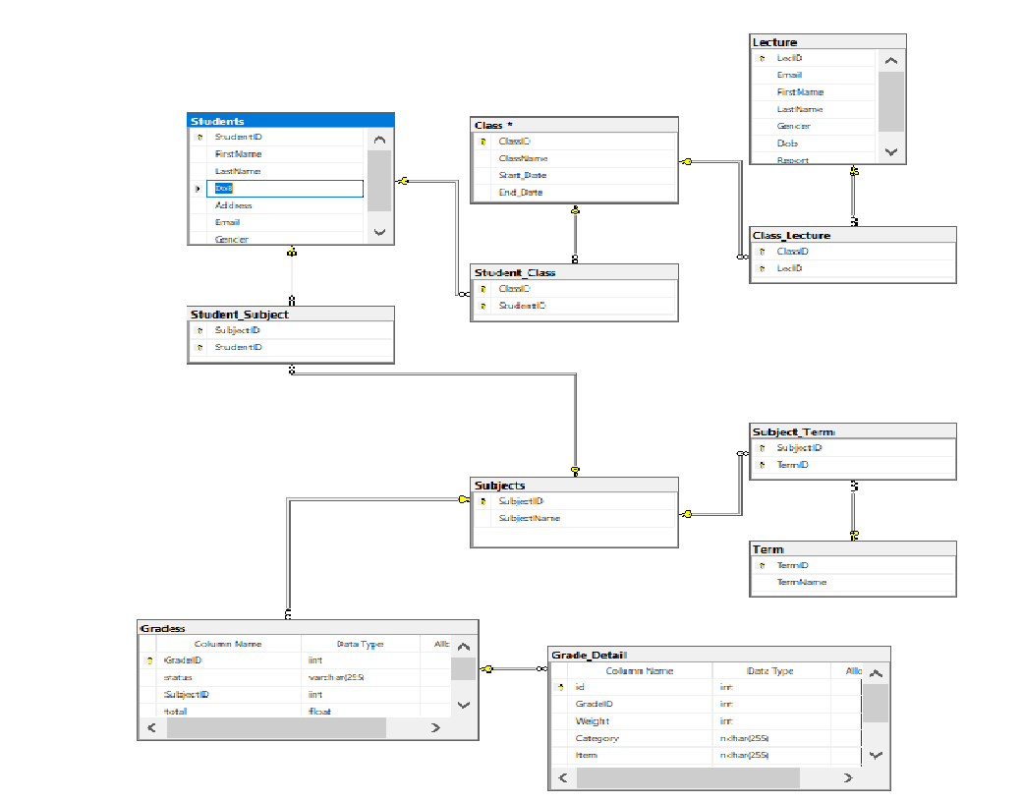

USE [master]

GO

/****** Object: Database [Assignment_ DBI202] Script Date: 7/15/2022 11:07:05 PM ******/

CREATE DATABASE [Assignment_ DBI202]

CONTAINMENT = NONE

ON PRIMARY

( NAME = N'Assignment_ DBI202', FILENAME = N'C:\Program Files\Microsoft SQL Server\MSSQL15.MAYAO\MSSQL\DATA\Assignment_ DBI202.mdf' , SIZE = 8192KB , MAXSIZE = UNLIMITED, FILEGROWTH = 65536KB )

LOG ON

( NAME = N'Assignment_ DBI202_log', FILENAME = N'C:\Program Files\Microsoft SQL Server\MSSQL15.MAYAO\MSSQL\DATA\Assignment_ DBI202_log.ldf' , SIZE = 8192KB , MAXSIZE = 2048GB , FILEGROWTH = 65536KB )

WITH CATALOG_COLLATION = DATABASE_DEFAULT

GO

ALTER DATABASE [Assignment_ DBI202] SET COMPATIBILITY_LEVEL = 150

GO

IF (1 = FULLTEXTSERVICEPROPERTY('IsFullTextInstalled'))

begin

EXEC [Assignment_ DBI202].[dbo].[sp_fulltext_database] @action = 'enable'

end

GO

ALTER DATABASE [Assignment_ DBI202] SET ANSI_NULL_DEFAULT OFF

GO

ALTER DATABASE [Assignment_ DBI202] SET ANSI_NULLS OFF

GO

ALTER DATABASE [Assignment_ DBI202] SET ANSI_PADDING OFF

GO

ALTER DATABASE [Assignment_ DBI202] SET ANSI_WARNINGS OFF

GO

ALTER DATABASE [Assignment_ DBI202] SET ARITHABORT OFF

GO

ALTER DATABASE [Assignment_ DBI202] SET AUTO_CLOSE OFF

GO

ALTER DATABASE [Assignment_ DBI202] SET AUTO_SHRINK OFF

GO

ALTER DATABASE [Assignment_ DBI202] SET AUTO_UPDATE_STATISTICS ON

GO

ALTER DATABASE [Assignment_ DBI202] SET CURSOR_CLOSE_ON_COMMIT OFF

GO

ALTER DATABASE [Assignment_ DBI202] SET CURSOR_DEFAULT GLOBAL

GO

ALTER DATABASE [Assignment_ DBI202] SET CONCAT_NULL_YIELDS_NULL OFF

GO

ALTER DATABASE [Assignment_ DBI202] SET NUMERIC_ROUNDABORT OFF

GO

ALTER DATABASE [Assignment_ DBI202] SET QUOTED_IDENTIFIER OFF

GO

ALTER DATABASE [Assignment_ DBI202] SET RECURSIVE_TRIGGERS OFF

GO

ALTER DATABASE [Assignment_ DBI202] SET DISABLE_BROKER

GO

ALTER DATABASE [Assignment_ DBI202] SET AUTO_UPDATE_STATISTICS_ASYNC OFF

GO

ALTER DATABASE [Assignment_ DBI202] SET DATE_CORRELATION_OPTIMIZATION OFF

GO

ALTER DATABASE [Assignment_ DBI202] SET TRUSTWORTHY OFF

GO

ALTER DATABASE [Assignment_ DBI202] SET ALLOW_SNAPSHOT_ISOLATION OFF

GO

ALTER DATABASE [Assignment_ DBI202] SET PARAMETERIZATION SIMPLE

GO

ALTER DATABASE [Assignment_ DBI202] SET READ_COMMITTED_SNAPSHOT OFF

GO

ALTER DATABASE [Assignment_ DBI202] SET HONOR_BROKER_PRIORITY OFF

GO

ALTER DATABASE [Assignment_ DBI202] SET RECOVERY FULL

GO

ALTER DATABASE [Assignment_ DBI202] SET MULTI_USER

GO

ALTER DATABASE [Assignment_ DBI202] SET PAGE_VERIFY CHECKSUM

GO

ALTER DATABASE [Assignment_ DBI202] SET DB_CHAINING OFF

GO

ALTER DATABASE [Assignment_ DBI202] SET FILESTREAM( NON_TRANSACTED_ACCESS = OFF )

GO

ALTER DATABASE [Assignment_ DBI202] SET TARGET_RECOVERY_TIME = 60 SECONDS

GO

ALTER DATABASE [Assignment_ DBI202] SET DELAYED_DURABILITY = DISABLED

GO

ALTER DATABASE [Assignment_ DBI202] SET ACCELERATED_DATABASE_RECOVERY = OFF

GO

EXEC sys.sp_db_vardecimal_storage_format N'Assignment_ DBI202', N'ON'

GO

ALTER DATABASE [Assignment_ DBI202] SET QUERY_STORE = OFF

GO

USE [Assignment_ DBI202]

GO

/****** Object: Table [dbo].[Class] Script Date: 7/15/2022 11:07:05 PM ******/

SET ANSI_NULLS ON

GO

SET QUOTED_IDENTIFIER ON

GO

CREATE TABLE [dbo].[Class](

[ClassID] [int] NOT NULL,

[ClassName] [varchar](50) NOT NULL,

[Start_Date] [date] NOT NULL,

[End_Date] [date] NOT NULL,

CONSTRAINT [PK_Class] PRIMARY KEY CLUSTERED

(

[ClassID] ASC

)WITH (PAD_INDEX = OFF, STATISTICS_NORECOMPUTE = OFF, IGNORE_DUP_KEY = OFF, ALLOW_ROW_LOCKS = ON, ALLOW_PAGE_LOCKS = ON, OPTIMIZE_FOR_SEQUENTIAL_KEY = OFF) ON [PRIMARY]

) ON [PRIMARY]

GO

/****** Object: Table [dbo].[Class_Lecture] Script Date: 7/15/2022 11:07:05 PM ******/

SET ANSI_NULLS ON

GO

SET QUOTED_IDENTIFIER ON

GO

CREATE TABLE [dbo].[Class_Lecture](

[ClassID] [int] NOT NULL,

[LecID] [int] NOT NULL,

CONSTRAINT [PK_Class_Lecture] PRIMARY KEY CLUSTERED

(

[ClassID] ASC,

[LecID] ASC

)WITH (PAD_INDEX = OFF, STATISTICS_NORECOMPUTE = OFF, IGNORE_DUP_KEY = OFF, ALLOW_ROW_LOCKS = ON, ALLOW_PAGE_LOCKS = ON, OPTIMIZE_FOR_SEQUENTIAL_KEY = OFF) ON [PRIMARY]

) ON [PRIMARY]

GO

/****** Object: Table [dbo].[Grade_Detail] Script Date: 7/15/2022 11:07:05 PM ******/

SET ANSI_NULLS ON

GO

SET QUOTED_IDENTIFIER ON

GO

CREATE TABLE [dbo].[Grade_Detail](

[id] [int] NOT NULL,

[GradeID] [int] NOT NULL,

[Weight] [int] NULL,

[Category] [nchar](255) NULL,

[Item] [nchar](255) NULL,

[Comment] [nchar](255) NULL,

[Value] [float] NOT NULL,

CONSTRAINT [PK_Grade_Detail] PRIMARY KEY CLUSTERED

(

[id] ASC

)WITH (PAD_INDEX = OFF, STATISTICS_NORECOMPUTE = OFF, IGNORE_DUP_KEY = OFF, ALLOW_ROW_LOCKS = ON, ALLOW_PAGE_LOCKS = ON, OPTIMIZE_FOR_SEQUENTIAL_KEY = OFF) ON [PRIMARY]

) ON [PRIMARY]

GO

/****** Object: Table [dbo].[Gradess] Script Date: 7/15/2022 11:07:05 PM ******/

SET ANSI_NULLS ON

GO

SET QUOTED_IDENTIFIER ON

GO

CREATE TABLE [dbo].[Gradess](

[GradeID] [int] NOT NULL,

[status] [varchar](255) NULL,

[SubjectID] [int] NOT NULL,

[total] [float] NULL,

CONSTRAINT [PK_Gradess] PRIMARY KEY CLUSTERED

(

[GradeID] ASC

)WITH (PAD_INDEX = OFF, STATISTICS_NORECOMPUTE = OFF, IGNORE_DUP_KEY = OFF, ALLOW_ROW_LOCKS = ON, ALLOW_PAGE_LOCKS = ON, OPTIMIZE_FOR_SEQUENTIAL_KEY = OFF) ON [PRIMARY]

) ON [PRIMARY]

GO

/****** Object: Table [dbo].[Lecture] Script Date: 7/15/2022 11:07:05 PM ******/

SET ANSI_NULLS ON

GO

SET QUOTED_IDENTIFIER ON

GO

CREATE TABLE [dbo].[Lecture](

[LecID] [int] NOT NULL,

[Email] [varchar](100) NOT NULL,

[FirstName] [nvarchar](10) NOT NULL,

[LastName] [nvarchar](50) NOT NULL,

[Gender] [bit] NULL,

[Dob] [date] NULL,

[Report] [nvarchar](50) NULL,

CONSTRAINT [PK_Lecture] PRIMARY KEY CLUSTERED

(

[LecID] ASC

)WITH (PAD_INDEX = OFF, STATISTICS_NORECOMPUTE = OFF, IGNORE_DUP_KEY = OFF, ALLOW_ROW_LOCKS = ON, ALLOW_PAGE_LOCKS = ON, OPTIMIZE_FOR_SEQUENTIAL_KEY = OFF) ON [PRIMARY]

) ON [PRIMARY]

GO

/****** Object: Table [dbo].[Student_Class] Script Date: 7/15/2022 11:07:05 PM ******/

SET ANSI_NULLS ON

GO

SET QUOTED_IDENTIFIER ON

GO

CREATE TABLE [dbo].[Student_Class](

[ClassID] [int] NOT NULL,

[StudentID] [varchar](10) NOT NULL,

CONSTRAINT [PK_Student_Class] PRIMARY KEY CLUSTERED

(

[ClassID] ASC,

[StudentID] ASC

)WITH (PAD_INDEX = OFF, STATISTICS_NORECOMPUTE = OFF, IGNORE_DUP_KEY = OFF, ALLOW_ROW_LOCKS = ON, ALLOW_PAGE_LOCKS = ON, OPTIMIZE_FOR_SEQUENTIAL_KEY = OFF) ON [PRIMARY]

) ON [PRIMARY]

GO

/****** Object: Table [dbo].[Student_Subject] Script Date: 7/15/2022 11:07:05 PM ******/

SET ANSI_NULLS ON

GO

SET QUOTED_IDENTIFIER ON

GO

CREATE TABLE [dbo].[Student_Subject](

[SubjectID] [int] NOT NULL,

[StudentID] [varchar](10) NOT NULL,

CONSTRAINT [PK_Student_Subject] PRIMARY KEY CLUSTERED

(

[SubjectID] ASC,

[StudentID] ASC

)WITH (PAD_INDEX = OFF, STATISTICS_NORECOMPUTE = OFF, IGNORE_DUP_KEY = OFF, ALLOW_ROW_LOCKS = ON, ALLOW_PAGE_LOCKS = ON, OPTIMIZE_FOR_SEQUENTIAL_KEY = OFF) ON [PRIMARY]

) ON [PRIMARY]

GO

/****** Object: Table [dbo].[Students] Script Date: 7/15/2022 11:07:05 PM ******/

SET ANSI_NULLS ON

GO

SET QUOTED_IDENTIFIER ON

GO

CREATE TABLE [dbo].[Students](

[StudentID] [varchar](10) NOT NULL,

[FirstName] [nvarchar](10) NOT NULL,

[LastName] [nvarchar](50) NOT NULL,

[DoB] [date] NOT NULL,

[Address] [nvarchar](150) NULL,

[Email] [varchar](100) NULL,

[Gender] [bit] NULL,

CONSTRAINT [PK_Students] PRIMARY KEY CLUSTERED

(

[StudentID] ASC

)WITH (PAD_INDEX = OFF, STATISTICS_NORECOMPUTE = OFF, IGNORE_DUP_KEY = OFF, ALLOW_ROW_LOCKS = ON, ALLOW_PAGE_LOCKS = ON, OPTIMIZE_FOR_SEQUENTIAL_KEY = OFF) ON [PRIMARY]

) ON [PRIMARY]

GO

/****** Object: Table [dbo].[Subject_Term] Script Date: 7/15/2022 11:07:05 PM ******/

SET ANSI_NULLS ON

GO

SET QUOTED_IDENTIFIER ON

GO

CREATE TABLE [dbo].[Subject_Term](

[SubjectID] [int] NOT NULL,

[TermID] [int] NOT NULL,

CONSTRAINT [PK_Subject_Term] PRIMARY KEY CLUSTERED

(

[SubjectID] ASC,

[TermID] ASC

)WITH (PAD_INDEX = OFF, STATISTICS_NORECOMPUTE = OFF, IGNORE_DUP_KEY = OFF, ALLOW_ROW_LOCKS = ON, ALLOW_PAGE_LOCKS = ON, OPTIMIZE_FOR_SEQUENTIAL_KEY = OFF) ON [PRIMARY]

) ON [PRIMARY]

GO

/****** Object: Table [dbo].[Subjects] Script Date: 7/15/2022 11:07:05 PM ******/

SET ANSI_NULLS ON

GO

SET QUOTED_IDENTIFIER ON

GO

CREATE TABLE [dbo].[Subjects](

[SubjectID] [int] NOT NULL,

[SubjectName] [varchar](50) NOT NULL,

CONSTRAINT [PK_Subjects] PRIMARY KEY CLUSTERED

(

[SubjectID] ASC

)WITH (PAD_INDEX = OFF, STATISTICS_NORECOMPUTE = OFF, IGNORE_DUP_KEY = OFF, ALLOW_ROW_LOCKS = ON, ALLOW_PAGE_LOCKS = ON, OPTIMIZE_FOR_SEQUENTIAL_KEY = OFF) ON [PRIMARY]

) ON [PRIMARY]

GO

/****** Object: Table [dbo].[Term] Script Date: 7/15/2022 11:07:05 PM ******/

SET ANSI_NULLS ON

GO

SET QUOTED_IDENTIFIER ON

GO

CREATE TABLE [dbo].[Term](

[TermID] [int] NOT NULL,

[TermName] [varchar](50) NOT NULL,

CONSTRAINT [PK_Term] PRIMARY KEY CLUSTERED

(

[TermID] ASC

)WITH (PAD_INDEX = OFF, STATISTICS_NORECOMPUTE = OFF, IGNORE_DUP_KEY = OFF, ALLOW_ROW_LOCKS = ON, ALLOW_PAGE_LOCKS = ON, OPTIMIZE_FOR_SEQUENTIAL_KEY = OFF) ON [PRIMARY]

) ON [PRIMARY]

GO

INSERT [dbo].[Class] ([ClassID], [ClassName], [Start_Date], [End_Date]) VALUES (1, N'IA1604', CAST(N'2022-05-09' AS Date), CAST(N'2022-08-09' AS Date))

INSERT [dbo].[Class] ([ClassID], [ClassName], [Start_Date], [End_Date]) VALUES (2, N'AI1601', CAST(N'2022-05-09' AS Date), CAST(N'2022-08-09' AS Date))

INSERT [dbo].[Class] ([ClassID], [ClassName], [Start_Date], [End_Date]) VALUES (3, N'SE1602', CAST(N'2022-09-09' AS Date), CAST(N'2022-11-09' AS Date))

INSERT [dbo].[Class] ([ClassID], [ClassName], [Start_Date], [End_Date]) VALUES (4, N'IA1605', CAST(N'2022-05-09' AS Date), CAST(N'2022-08-09' AS Date))

INSERT [dbo].[Class] ([ClassID], [ClassName], [Start_Date], [End_Date]) VALUES (5, N'IA1606', CAST(N'2022-05-09' AS Date), CAST(N'2022-08-09' AS Date))

INSERT [dbo].[Class] ([ClassID], [ClassName], [Start_Date], [End_Date]) VALUES (6, N'IA1607', CAST(N'2022-05-09' AS Date), CAST(N'2022-08-09' AS Date))

INSERT [dbo].[Class] ([ClassID], [ClassName], [Start_Date], [End_Date]) VALUES (7, N'AI1602', CAST(N'2022-09-09' AS Date), CAST(N'2022-11-09' AS Date))

INSERT [dbo].[Class] ([ClassID], [ClassName], [Start_Date], [End_Date]) VALUES (9, N'AI1603', CAST(N'2022-09-09' AS Date), CAST(N'2022-11-09' AS Date))

INSERT [dbo].[Class] ([ClassID], [ClassName], [Start_Date], [End_Date]) VALUES (10, N'AI1604', CAST(N'2022-09-09' AS Date), CAST(N'2022-11-09' AS Date))

INSERT [dbo].[Class] ([ClassID], [ClassName], [Start_Date], [End_Date]) VALUES (11, N'SE1603', CAST(N'2022-09-09' AS Date), CAST(N'2022-11-09' AS Date))

INSERT [dbo].[Class] ([ClassID], [ClassName], [Start_Date], [End_Date]) VALUES (12, N'SE1604', CAST(N'2022-04-06' AS Date), CAST(N'2022-07-01' AS Date))

GO

INSERT [dbo].[Class_Lecture] ([ClassID], [LecID]) VALUES (1, 1)

INSERT [dbo].[Class_Lecture] ([ClassID], [LecID]) VALUES (1, 2)

INSERT [dbo].[Class_Lecture] ([ClassID], [LecID]) VALUES (1, 3)

INSERT [dbo].[Class_Lecture] ([ClassID], [LecID]) VALUES (2, 1)

INSERT [dbo].[Class_Lecture] ([ClassID], [LecID]) VALUES (2, 2)

INSERT [dbo].[Class_Lecture] ([ClassID], [LecID]) VALUES (2, 3)

INSERT [dbo].[Class_Lecture] ([ClassID], [LecID]) VALUES (2, 4)

INSERT [dbo].[Class_Lecture] ([ClassID], [LecID]) VALUES (3, 1)

INSERT [dbo].[Class_Lecture] ([ClassID], [LecID]) VALUES (3, 2)

INSERT [dbo].[Class_Lecture] ([ClassID], [LecID]) VALUES (3, 5)

INSERT [dbo].[Class_Lecture] ([ClassID], [LecID]) VALUES (4, 1)

INSERT [dbo].[Class_Lecture] ([ClassID], [LecID]) VALUES (4, 2)

INSERT [dbo].[Class_Lecture] ([ClassID], [LecID]) VALUES (4, 5)

INSERT [dbo].[Class_Lecture] ([ClassID], [LecID]) VALUES (4, 9)

INSERT [dbo].[Class_Lecture] ([ClassID], [LecID]) VALUES (5, 1)

INSERT [dbo].[Class_Lecture] ([ClassID], [LecID]) VALUES (5, 2)

INSERT [dbo].[Class_Lecture] ([ClassID], [LecID]) VALUES (5, 8)

INSERT [dbo].[Class_Lecture] ([ClassID], [LecID]) VALUES (6, 1)

INSERT [dbo].[Class_Lecture] ([ClassID], [LecID]) VALUES (6, 2)

INSERT [dbo].[Class_Lecture] ([ClassID], [LecID]) VALUES (6, 3)

INSERT [dbo].[Class_Lecture] ([ClassID], [LecID]) VALUES (6, 7)

INSERT [dbo].[Class_Lecture] ([ClassID], [LecID]) VALUES (7, 1)

INSERT [dbo].[Class_Lecture] ([ClassID], [LecID]) VALUES (7, 5)

INSERT [dbo].[Class_Lecture] ([ClassID], [LecID]) VALUES (7, 7)

INSERT [dbo].[Class_Lecture] ([ClassID], [LecID]) VALUES (7, 9)

INSERT [dbo].[Class_Lecture] ([ClassID], [LecID]) VALUES (10, 9)

INSERT [dbo].[Class_Lecture] ([ClassID], [LecID]) VALUES (11, 7)

INSERT [dbo].[Class_Lecture] ([ClassID], [LecID]) VALUES (11, 8)

INSERT [dbo].[Class_Lecture] ([ClassID], [LecID]) VALUES (12, 3)

INSERT [dbo].[Class_Lecture] ([ClassID], [LecID]) VALUES (12, 8)

GO

INSERT [dbo].[Grade_Detail] ([id], [GradeID], [Weight], [Category], [Item], [Comment], [Value]) VALUES (1, 1, 10, N'Avtive learning ', N'Active Learning ', NULL, 7)

INSERT [dbo].[Grade_Detail] ([id], [GradeID], [Weight], [Category], [Item], [Comment], [Value]) VALUES (2, 1, 5, N'Exercise ', N'Excercise 1 ', NULL, 8)

INSERT [dbo].[Grade_Detail] ([id], [GradeID], [Weight], [Category], [Item], [Comment], [Value]) VALUES (3, 1, 5, N'Excercise ', N'Excercise 2 ', NULL, 8.5)

INSERT [dbo].[Grade_Detail] ([id], [GradeID], [Weight], [Category], [Item], [Comment], [Value]) VALUES (4, 1, 10, N'Presentation ', N'Presentation ', NULL, 8)

INSERT [dbo].[Grade_Detail] ([id], [GradeID], [Weight], [Category], [Item], [Comment], [Value]) VALUES (5, 1, 30, N'Assignment ', N'Assignment ', NULL, 8.5)

INSERT [dbo].[Grade_Detail] ([id], [GradeID], [Weight], [Category], [Item], [Comment], [Value]) VALUES (6, 1, 40, N'Final Exam ', N'Final Exam ', NULL, 8)

INSERT [dbo].[Grade_Detail] ([id], [GradeID], [Weight], [Category], [Item], [Comment], [Value]) VALUES (7, 2, 10, N'Active learning ', N'Active learning ', NULL, 7)

INSERT [dbo].[Grade_Detail] ([id], [GradeID], [Weight], [Category], [Item], [Comment], [Value]) VALUES (8, 2, 5, NULL, NULL, NULL, 0)

INSERT [dbo].[Grade_Detail] ([id], [GradeID], [Weight], [Category], [Item], [Comment], [Value]) VALUES (9, 2, 10, N'Presentation ', N'Presentation ', NULL, 5)

INSERT [dbo].[Grade_Detail] ([id], [GradeID], [Weight], [Category], [Item], [Comment], [Value]) VALUES (10, 2, 40, N'Final Exam ', N'Final Exam ', NULL, 3.9)

GO

INSERT [dbo].[Gradess] ([GradeID], [status], [SubjectID], [total]) VALUES (1, N'Passed', 1, 8.1)

INSERT [dbo].[Gradess] ([GradeID], [status], [SubjectID], [total]) VALUES (2, N'Passed', 1, 7)

INSERT [dbo].[Gradess] ([GradeID], [status], [SubjectID], [total]) VALUES (3, N'Passed', 1, 9)

INSERT [dbo].[Gradess] ([GradeID], [status], [SubjectID], [total]) VALUES (4, N'Not passed ', 2, 4.5)

INSERT [dbo].[Gradess] ([GradeID], [status], [SubjectID], [total]) VALUES (5, N'Passed', 1, 5.6)

INSERT [dbo].[Gradess] ([GradeID], [status], [SubjectID], [total]) VALUES (6, N'Not passed', 2, 4.9)

INSERT [dbo].[Gradess] ([GradeID], [status], [SubjectID], [total]) VALUES (7, N'Not passed', 3, 5.9)

INSERT [dbo].[Gradess] ([GradeID], [status], [SubjectID], [total]) VALUES (8, N'Not passed', 3, 3.5)

INSERT [dbo].[Gradess] ([GradeID], [status], [SubjectID], [total]) VALUES (9, N'Passed ', 3, 10)

INSERT [dbo].[Gradess] ([GradeID], [status], [SubjectID], [total]) VALUES (10, N'Passed', 3, 7.6)

INSERT [dbo].[Gradess] ([GradeID], [status], [SubjectID], [total]) VALUES (11, N'Passed', 4, 7)

INSERT [dbo].[Gradess] ([GradeID], [status], [SubjectID], [total]) VALUES (12, N'Passed', 4, 6.7)

INSERT [dbo].[Gradess] ([GradeID], [status], [SubjectID], [total]) VALUES (13, NULL, 4, 0)

INSERT [dbo].[Gradess] ([GradeID], [status], [SubjectID], [total]) VALUES (14, NULL, 4, 0)

INSERT [dbo].[Gradess] ([GradeID], [status], [SubjectID], [total]) VALUES (15, N'Passed', 4, 8.2)

INSERT [dbo].[Gradess] ([GradeID], [status], [SubjectID], [total]) VALUES (16, N'Passed', 5, 7.2)

INSERT [dbo].[Gradess] ([GradeID], [status], [SubjectID], [total]) VALUES (17, N'Not Passed', 5, 2.3)

INSERT [dbo].[Gradess] ([GradeID], [status], [SubjectID], [total]) VALUES (18, NULL, 5, 0)

INSERT [dbo].[Gradess] ([GradeID], [status], [SubjectID], [total]) VALUES (19, NULL, 5, 1.1)

INSERT [dbo].[Gradess] ([GradeID], [status], [SubjectID], [total]) VALUES (20, NULL, 5, 0.2)

INSERT [dbo].[Gradess] ([GradeID], [status], [SubjectID], [total]) VALUES (21, NULL, 5, 0.3)

INSERT [dbo].[Gradess] ([GradeID], [status], [SubjectID], [total]) VALUES (22, NULL, 6, 0)

INSERT [dbo].[Gradess] ([GradeID], [status], [SubjectID], [total]) VALUES (23, N'Passed', 6, 9.8)

INSERT [dbo].[Gradess] ([GradeID], [status], [SubjectID], [total]) VALUES (24, N'Passed', 6, 9.4)

INSERT [dbo].[Gradess] ([GradeID], [status], [SubjectID], [total]) VALUES (25, N'Passed', 6, 9)

INSERT [dbo].[Gradess] ([GradeID], [status], [SubjectID], [total]) VALUES (26, N'Passed', 6, 7.7)

INSERT [dbo].[Gradess] ([GradeID], [status], [SubjectID], [total]) VALUES (27, N'Passed', 6, 6.6)

INSERT [dbo].[Gradess] ([GradeID], [status], [SubjectID], [total]) VALUES (28, N'Passed', 7, 7)

INSERT [dbo].[Gradess] ([GradeID], [status], [SubjectID], [total]) VALUES (29, N'Not passed', 7, 4.4)

INSERT [dbo].[Gradess] ([GradeID], [status], [SubjectID], [total]) VALUES (30, N'Not passed ', 7, 4)

GO

INSERT [dbo].[Lecture] ([LecID], [Email], [FirstName], [LastName], [Gender], [Dob], [Report]) VALUES (1, N'Sonnt5@g.c', N'Sơn', N'NT', 1, CAST(N'1987-05-06' AS Date), NULL)

INSERT [dbo].[Lecture] ([LecID], [Email], [FirstName], [LastName], [Gender], [Dob], [Report]) VALUES (2, N'Antt@g.c', N'Ân', N'TT', 1, CAST(N'1988-02-04' AS Date), N'1')

INSERT [dbo].[Lecture] ([LecID], [Email], [FirstName], [LastName], [Gender], [Dob], [Report]) VALUES (3, N'Nangnt@g.c', N'Năng', N'NT', 0, CAST(N'1990-03-06' AS Date), N'1')

INSERT [dbo].[Lecture] ([LecID], [Email], [FirstName], [LastName], [Gender], [Dob], [Report]) VALUES (4, N'Vandt@g.c', N'Vân', N'DT', 0, CAST(N'1989-08-02' AS Date), NULL)

INSERT [dbo].[Lecture] ([LecID], [Email], [FirstName], [LastName], [Gender], [Dob], [Report]) VALUES (5, N'Duchm@g.c', N'Đức', N'HM', 1, CAST(N'1985-05-01' AS Date), NULL)

INSERT [dbo].[Lecture] ([LecID], [Email], [FirstName], [LastName], [Gender], [Dob], [Report]) VALUES (6, N'Khuongpd@g.c', N'Khương', N'PD', 1, CAST(N'1989-01-11' AS Date), NULL)

INSERT [dbo].[Lecture] ([LecID], [Email], [FirstName], [LastName], [Gender], [Dob], [Report]) VALUES (7, N'Tientd@g.c', N'Tiến', N'TD', 1, CAST(N'1980-05-06' AS Date), N'1')

INSERT [dbo].[Lecture] ([LecID], [Email], [FirstName], [LastName], [Gender], [Dob], [Report]) VALUES (8, N'Mailt@g.c', N'Mai', N'LT', 0, CAST(N'1988-04-16' AS Date), NULL)

INSERT [dbo].[Lecture] ([LecID], [Email], [FirstName], [LastName], [Gender], [Dob], [Report]) VALUES (9, N'Hoakt@g.c', N'Hoa', N'KT', 0, CAST(N'1995-08-18' AS Date), NULL)

GO

INSERT [dbo].[Student_Class] ([ClassID], [StudentID]) VALUES (1, N'HE111')

INSERT [dbo].[Student_Class] ([ClassID], [StudentID]) VALUES (1, N'HE112')

INSERT [dbo].[Student_Class] ([ClassID], [StudentID]) VALUES (1, N'HE113')

INSERT [dbo].[Student_Class] ([ClassID], [StudentID]) VALUES (1, N'HE116')

INSERT [dbo].[Student_Class] ([ClassID], [StudentID]) VALUES (1, N'HE117')

INSERT [dbo].[Student_Class] ([ClassID], [StudentID]) VALUES (1, N'HE118')

INSERT [dbo].[Student_Class] ([ClassID], [StudentID]) VALUES (2, N'HE111')

INSERT [dbo].[Student_Class] ([ClassID], [StudentID]) VALUES (2, N'HE112')

INSERT [dbo].[Student_Class] ([ClassID], [StudentID]) VALUES (2, N'HE114')

INSERT [dbo].[Student_Class] ([ClassID], [StudentID]) VALUES (2, N'HE116')

INSERT [dbo].[Student_Class] ([ClassID], [StudentID]) VALUES (3, N'HE111')

INSERT [dbo].[Student_Class] ([ClassID], [StudentID]) VALUES (3, N'HE113')

INSERT [dbo].[Student_Class] ([ClassID], [StudentID]) VALUES (3, N'HE115')

INSERT [dbo].[Student_Class] ([ClassID], [StudentID]) VALUES (4, N'HE111')

INSERT [dbo].[Student_Class] ([ClassID], [StudentID]) VALUES (4, N'HE112')

INSERT [dbo].[Student_Class] ([ClassID], [StudentID]) VALUES (4, N'HE114')

INSERT [dbo].[Student_Class] ([ClassID], [StudentID]) VALUES (4, N'HE115')

INSERT [dbo].[Student_Class] ([ClassID], [StudentID]) VALUES (4, N'HE119')

INSERT [dbo].[Student_Class] ([ClassID], [StudentID]) VALUES (4, N'HE120')

INSERT [dbo].[Student_Class] ([ClassID], [StudentID]) VALUES (5, N'HE111')

INSERT [dbo].[Student_Class] ([ClassID], [StudentID]) VALUES (5, N'HE113')

INSERT [dbo].[Student_Class] ([ClassID], [StudentID]) VALUES (5, N'HE116')

INSERT [dbo].[Student_Class] ([ClassID], [StudentID]) VALUES (5, N'HE117')

INSERT [dbo].[Student_Class] ([ClassID], [StudentID]) VALUES (5, N'HE118')

INSERT [dbo].[Student_Class] ([ClassID], [StudentID]) VALUES (5, N'HE120')

INSERT [dbo].[Student_Class] ([ClassID], [StudentID]) VALUES (6, N'HE111')

INSERT [dbo].[Student_Class] ([ClassID], [StudentID]) VALUES (6, N'HE112')

INSERT [dbo].[Student_Class] ([ClassID], [StudentID]) VALUES (6, N'HE113')

INSERT [dbo].[Student_Class] ([ClassID], [StudentID]) VALUES (6, N'HE114')

INSERT [dbo].[Student_Class] ([ClassID], [StudentID]) VALUES (6, N'HE115')

INSERT [dbo].[Student_Class] ([ClassID], [StudentID]) VALUES (6, N'HE117')

INSERT [dbo].[Student_Class] ([ClassID], [StudentID]) VALUES (6, N'HE120')

INSERT [dbo].[Student_Class] ([ClassID], [StudentID]) VALUES (7, N'HE111')

INSERT [dbo].[Student_Class] ([ClassID], [StudentID]) VALUES (7, N'HE112')

INSERT [dbo].[Student_Class] ([ClassID], [StudentID]) VALUES (7, N'HE113')

INSERT [dbo].[Student_Class] ([ClassID], [StudentID]) VALUES (7, N'HE117')

INSERT [dbo].[Student_Class] ([ClassID], [StudentID]) VALUES (7, N'HE118')

INSERT [dbo].[Student_Class] ([ClassID], [StudentID]) VALUES (7, N'HE120')

GO

INSERT [dbo].[Student_Subject] ([SubjectID], [StudentID]) VALUES (1, N'HE111')

INSERT [dbo].[Student_Subject] ([SubjectID], [StudentID]) VALUES (1, N'HE112')

INSERT [dbo].[Student_Subject] ([SubjectID], [StudentID]) VALUES (1, N'HE113')

INSERT [dbo].[Student_Subject] ([SubjectID], [StudentID]) VALUES (2, N'HE111')

INSERT [dbo].[Student_Subject] ([SubjectID], [StudentID]) VALUES (2, N'HE113')

INSERT [dbo].[Student_Subject] ([SubjectID], [StudentID]) VALUES (2, N'HE114')

INSERT [dbo].[Student_Subject] ([SubjectID], [StudentID]) VALUES (2, N'HE115')

INSERT [dbo].[Student_Subject] ([SubjectID], [StudentID]) VALUES (3, N'HE111')

INSERT [dbo].[Student_Subject] ([SubjectID], [StudentID]) VALUES (3, N'HE112')

INSERT [dbo].[Student_Subject] ([SubjectID], [StudentID]) VALUES (3, N'HE113')

INSERT [dbo].[Student_Subject] ([SubjectID], [StudentID]) VALUES (3, N'HE114')

INSERT [dbo].[Student_Subject] ([SubjectID], [StudentID]) VALUES (3, N'HE116')

INSERT [dbo].[Student_Subject] ([SubjectID], [StudentID]) VALUES (4, N'HE111')

INSERT [dbo].[Student_Subject] ([SubjectID], [StudentID]) VALUES (4, N'HE116')

INSERT [dbo].[Student_Subject] ([SubjectID], [StudentID]) VALUES (5, N'HE111')

INSERT [dbo].[Student_Subject] ([SubjectID], [StudentID]) VALUES (5, N'HE112')

INSERT [dbo].[Student_Subject] ([SubjectID], [StudentID]) VALUES (5, N'HE115')

INSERT [dbo].[Student_Subject] ([SubjectID], [StudentID]) VALUES (5, N'HE116')

INSERT [dbo].[Student_Subject] ([SubjectID], [StudentID]) VALUES (6, N'HE111')

INSERT [dbo].[Student_Subject] ([SubjectID], [StudentID]) VALUES (6, N'HE112')

INSERT [dbo].[Student_Subject] ([SubjectID], [StudentID]) VALUES (6, N'HE114')

INSERT [dbo].[Student_Subject] ([SubjectID], [StudentID]) VALUES (6, N'HE118')

INSERT [dbo].[Student_Subject] ([SubjectID], [StudentID]) VALUES (6, N'HE120')

INSERT [dbo].[Student_Subject] ([SubjectID], [StudentID]) VALUES (7, N'HE111')

INSERT [dbo].[Student_Subject] ([SubjectID], [StudentID]) VALUES (7, N'HE112')

INSERT [dbo].[Student_Subject] ([SubjectID], [StudentID]) VALUES (7, N'HE113')

INSERT [dbo].[Student_Subject] ([SubjectID], [StudentID]) VALUES (7, N'HE118')

INSERT [dbo].[Student_Subject] ([SubjectID], [StudentID]) VALUES (7, N'HE119')

INSERT [dbo].[Student_Subject] ([SubjectID], [StudentID]) VALUES (7, N'HE120')

INSERT [dbo].[Student_Subject] ([SubjectID], [StudentID]) VALUES (8, N'HE111')

INSERT [dbo].[Student_Subject] ([SubjectID], [StudentID]) VALUES (8, N'HE114')

INSERT [dbo].[Student_Subject] ([SubjectID], [StudentID]) VALUES (8, N'HE115')

INSERT [dbo].[Student_Subject] ([SubjectID], [StudentID]) VALUES (8, N'HE117')

INSERT [dbo].[Student_Subject] ([SubjectID], [StudentID]) VALUES (8, N'HE119')

INSERT [dbo].[Student_Subject] ([SubjectID], [StudentID]) VALUES (8, N'HE120')

INSERT [dbo].[Student_Subject] ([SubjectID], [StudentID]) VALUES (9, N'HE111')

INSERT [dbo].[Student_Subject] ([SubjectID], [StudentID]) VALUES (9, N'HE112')

INSERT [dbo].[Student_Subject] ([SubjectID], [StudentID]) VALUES (9, N'HE116')

INSERT [dbo].[Student_Subject] ([SubjectID], [StudentID]) VALUES (9, N'HE120')

INSERT [dbo].[Student_Subject] ([SubjectID], [StudentID]) VALUES (10, N'HE111')

INSERT [dbo].[Student_Subject] ([SubjectID], [StudentID]) VALUES (10, N'HE112')

INSERT [dbo].[Student_Subject] ([SubjectID], [StudentID]) VALUES (10, N'HE113')

INSERT [dbo].[Student_Subject] ([SubjectID], [StudentID]) VALUES (10, N'HE114')

INSERT [dbo].[Student_Subject] ([SubjectID], [StudentID]) VALUES (10, N'HE116')

INSERT [dbo].[Student_Subject] ([SubjectID], [StudentID]) VALUES (10, N'HE118')

INSERT [dbo].[Student_Subject] ([SubjectID], [StudentID]) VALUES (10, N'HE120')

GO

INSERT [dbo].[Students] ([StudentID], [FirstName], [LastName], [DoB], [Address], [Email], [Gender]) VALUES (N'HE111', N'NV', N'A', CAST(N'2002-05-02' AS Date), NULL, N'He111@g.c', 1)

INSERT [dbo].[Students] ([StudentID], [FirstName], [LastName], [DoB], [Address], [Email], [Gender]) VALUES (N'HE112', N'NB', N'B', CAST(N'2001-02-03' AS Date), N'Việt Nam', N'He112@g.c', 0)

INSERT [dbo].[Students] ([StudentID], [FirstName], [LastName], [DoB], [Address], [Email], [Gender]) VALUES (N'HE113', N'HB', N'C', CAST(N'2002-08-06' AS Date), N'Việt Nam', N'He113@g.c', 0)

INSERT [dbo].[Students] ([StudentID], [FirstName], [LastName], [DoB], [Address], [Email], [Gender]) VALUES (N'HE114', N'KH', N'D', CAST(N'2000-04-05' AS Date), NULL, N'He114@g.c', 1)

INSERT [dbo].[Students] ([StudentID], [FirstName], [LastName], [DoB], [Address], [Email], [Gender]) VALUES (N'HE115', N'BV', N'E', CAST(N'2002-08-06' AS Date), N'Việt Nam', N'He115@g.c', 1)

INSERT [dbo].[Students] ([StudentID], [FirstName], [LastName], [DoB], [Address], [Email], [Gender]) VALUES (N'HE116', N'NT', N'P', CAST(N'2001-07-03' AS Date), N'Mỹ', N'He116@g.c', 0)

INSERT [dbo].[Students] ([StudentID], [FirstName], [LastName], [DoB], [Address], [Email], [Gender]) VALUES (N'HE117', N'NG', N'A', CAST(N'2002-05-03' AS Date), NULL, N'He117@g.c', 1)

INSERT [dbo].[Students] ([StudentID], [FirstName], [LastName], [DoB], [Address], [Email], [Gender]) VALUES (N'HE118', N'NV', N'B', CAST(N'2001-07-15' AS Date), N'Việt Nam', N'He118@g.c', 1)

INSERT [dbo].[Students] ([StudentID], [FirstName], [LastName], [DoB], [Address], [Email], [Gender]) VALUES (N'HE119', N'TV', N'N', CAST(N'2002-11-05' AS Date), N'Việt Nam', N'He119@g.c', 1)

INSERT [dbo].[Students] ([StudentID], [FirstName], [LastName], [DoB], [Address], [Email], [Gender]) VALUES (N'HE120', N'NM', N'H', CAST(N'2001-01-11' AS Date), NULL, N'He120@g.c', 0)

GO

INSERT [dbo].[Subject_Term] ([SubjectID], [TermID]) VALUES (1, 1)

INSERT [dbo].[Subject_Term] ([SubjectID], [TermID]) VALUES (1, 2)

INSERT [dbo].[Subject_Term] ([SubjectID], [TermID]) VALUES (1, 4)

INSERT [dbo].[Subject_Term] ([SubjectID], [TermID]) VALUES (1, 5)

INSERT [dbo].[Subject_Term] ([SubjectID], [TermID]) VALUES (2, 1)

INSERT [dbo].[Subject_Term] ([SubjectID], [TermID]) VALUES (3, 1)

INSERT [dbo].[Subject_Term] ([SubjectID], [TermID]) VALUES (4, 2)

INSERT [dbo].[Subject_Term] ([SubjectID], [TermID]) VALUES (4, 3)

INSERT [dbo].[Subject_Term] ([SubjectID], [TermID]) VALUES (5, 1)

INSERT [dbo].[Subject_Term] ([SubjectID], [TermID]) VALUES (6, 1)

INSERT [dbo].[Subject_Term] ([SubjectID], [TermID]) VALUES (6, 2)

INSERT [dbo].[Subject_Term] ([SubjectID], [TermID]) VALUES (7, 1)

INSERT [dbo].[Subject_Term] ([SubjectID], [TermID]) VALUES (7, 2)

INSERT [dbo].[Subject_Term] ([SubjectID], [TermID]) VALUES (7, 3)

INSERT [dbo].[Subject_Term] ([SubjectID], [TermID]) VALUES (8, 1)

INSERT [dbo].[Subject_Term] ([SubjectID], [TermID]) VALUES (8, 3)

INSERT [dbo].[Subject_Term] ([SubjectID], [TermID]) VALUES (9, 6)

INSERT [dbo].[Subject_Term] ([SubjectID], [TermID]) VALUES (10, 6)

GO

INSERT [dbo].[Subjects] ([SubjectID], [SubjectName]) VALUES (1, N'DBI202')

INSERT [dbo].[Subjects] ([SubjectID], [SubjectName]) VALUES (2, N'LAB211')

INSERT [dbo].[Subjects] ([SubjectID], [SubjectName]) VALUES (3, N'CSD201')

INSERT [dbo].[Subjects] ([SubjectID], [SubjectName]) VALUES (4, N'JPD113')

INSERT [dbo].[Subjects] ([SubjectID], [SubjectName]) VALUES (5, N'IAO202')

INSERT [dbo].[Subjects] ([SubjectID], [SubjectName]) VALUES (6, N'PRO192')

INSERT [dbo].[Subjects] ([SubjectID], [SubjectName]) VALUES (7, N'OSG202')

INSERT [dbo].[Subjects] ([SubjectID], [SubjectName]) VALUES (8, N'SSG104')

INSERT [dbo].[Subjects] ([SubjectID], [SubjectName]) VALUES (9, N'MAD101')

INSERT [dbo].[Subjects] ([SubjectID], [SubjectName]) VALUES (10, N'NWC204')

GO

INSERT [dbo].[Term] ([TermID], [TermName]) VALUES (1, N'Fall2021')

INSERT [dbo].[Term] ([TermID], [TermName]) VALUES (2, N'Spr2022')

INSERT [dbo].[Term] ([TermID], [TermName]) VALUES (3, N'Su2022')

INSERT [dbo].[Term] ([TermID], [TermName]) VALUES (4, N'Su2021')

INSERT [dbo].[Term] ([TermID], [TermName]) VALUES (5, N'Spr2021')

INSERT [dbo].[Term] ([TermID], [TermName]) VALUES (6, N'Fall2022')

GO

ALTER TABLE [dbo].[Class_Lecture] WITH CHECK ADD CONSTRAINT [FK_Class_Lecture_Class] FOREIGN KEY([ClassID])

REFERENCES [dbo].[Class] ([ClassID])

GO

ALTER TABLE [dbo].[Class_Lecture] CHECK CONSTRAINT [FK_Class_Lecture_Class]

GO

ALTER TABLE [dbo].[Class_Lecture] WITH CHECK ADD CONSTRAINT [FK_Class_Lecture_Lecture] FOREIGN KEY([LecID])

REFERENCES [dbo].[Lecture] ([LecID])

GO

ALTER TABLE [dbo].[Class_Lecture] CHECK CONSTRAINT [FK_Class_Lecture_Lecture]

GO

ALTER TABLE [dbo].[Grade_Detail] WITH CHECK ADD CONSTRAINT [FK_Grade_Detail_Gradess1] FOREIGN KEY([GradeID])

REFERENCES [dbo].[Gradess] ([GradeID])

GO

ALTER TABLE [dbo].[Grade_Detail] CHECK CONSTRAINT [FK_Grade_Detail_Gradess1]

GO

ALTER TABLE [dbo].[Gradess] WITH CHECK ADD CONSTRAINT [FK_Gradess_Subjects] FOREIGN KEY([SubjectID])

REFERENCES [dbo].[Subjects] ([SubjectID])

GO

ALTER TABLE [dbo].[Gradess] CHECK CONSTRAINT [FK_Gradess_Subjects]

GO

ALTER TABLE [dbo].[Student_Class] WITH CHECK ADD CONSTRAINT [FK_Student_Class_Class] FOREIGN KEY([ClassID])

REFERENCES [dbo].[Class] ([ClassID])

GO

ALTER TABLE [dbo].[Student_Class] CHECK CONSTRAINT [FK_Student_Class_Class]

GO

ALTER TABLE [dbo].[Student_Class] WITH CHECK ADD CONSTRAINT [FK_Student_Class_Students] FOREIGN KEY([StudentID])

REFERENCES [dbo].[Students] ([StudentID])

GO

ALTER TABLE [dbo].[Student_Class] CHECK CONSTRAINT [FK_Student_Class_Students]

GO

ALTER TABLE [dbo].[Student_Subject] WITH CHECK ADD CONSTRAINT [FK_Student_Subject_Students] FOREIGN KEY([StudentID])

REFERENCES [dbo].[Students] ([StudentID])

GO

ALTER TABLE [dbo].[Student_Subject] CHECK CONSTRAINT [FK_Student_Subject_Students]

GO

ALTER TABLE [dbo].[Student_Subject] WITH CHECK ADD CONSTRAINT [FK_Student_Subject_Subjects] FOREIGN KEY([SubjectID])

REFERENCES [dbo].[Subjects] ([SubjectID])

GO

ALTER TABLE [dbo].[Student_Subject] CHECK CONSTRAINT [FK_Student_Subject_Subjects]

GO

ALTER TABLE [dbo].[Subject_Term] WITH CHECK ADD CONSTRAINT [FK_Subject_Term_Subjects] FOREIGN KEY([SubjectID])

REFERENCES [dbo].[Subjects] ([SubjectID])

GO

ALTER TABLE [dbo].[Subject_Term] CHECK CONSTRAINT [FK_Subject_Term_Subjects]

GO

ALTER TABLE [dbo].[Subject_Term] WITH CHECK ADD CONSTRAINT [FK_Subject_Term_Term] FOREIGN KEY([TermID])

REFERENCES [dbo].[Term] ([TermID])

GO

ALTER TABLE [dbo].[Subject_Term] CHECK CONSTRAINT [FK_Subject_Term_Term]

GO

USE [master]

GO

ALTER DATABASE [Assignment_ DBI202] SET READ_WRITE

GO

### Image + Results

1. Table Students

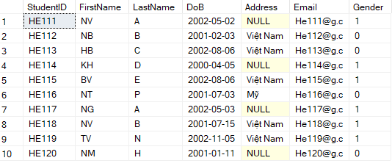

1. Table Lecture

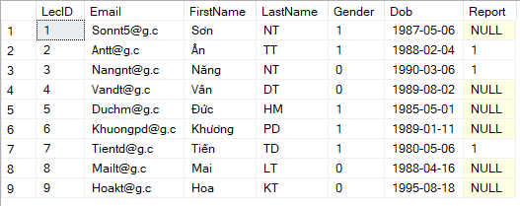

1. Table Classs

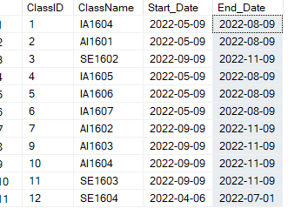

1. Table Subject

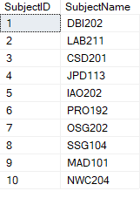

1. Table Term

